**Homework Week 1**

**Question 1** Which of the following is true?   
The propositional statement (P & Q) → (P v Q)

1. Satisfiable but not valid
2. Valid
3. A contradiction
4. None of the above

Justify your answer.

**Answer 1: b.**

**Explanation: We can rewrite the formula as**

**¬(P ∧ Q) ∨ (P ∨ Q), and then into ¬P ∨ ¬Q ∨ P ∨ Q.**

**It turns out to be a tautology given (¬P ∨ P) ∨ Q ∨ ¬Q, which is TRUE given all assignments of variables.**

**In another way, we can draw the truth table of the statement:**

|  |  |  |  |  |
| --- | --- | --- | --- | --- |
| **P** | **Q** | **P & Q** | **P v Q** | **(P & Q) → (P v Q)** |
| 0 | 0 | 0 | 0 | 1 |
| 0 | 1 | 0 | 1 | 1 |
| 1 | 0 | 0 | 1 | 1 |
| 1 | 1 | 1 | 1 | 1 |

**Question 2:** If F is a formula over n different letters in propositional logic, answer for each of the 4 cases a-d how many models (satisfying truth assignments) F has:  
a. if F is inconsistent   
b. if F is satisfiable   
c. if F is unsatisfiable   
d. if F is valid

**Answer 2:**

1. **0**
2. **greater than or equal to 1, less than or equal to 2^n**
3. **0**
4. **2^n**

**Question 3**

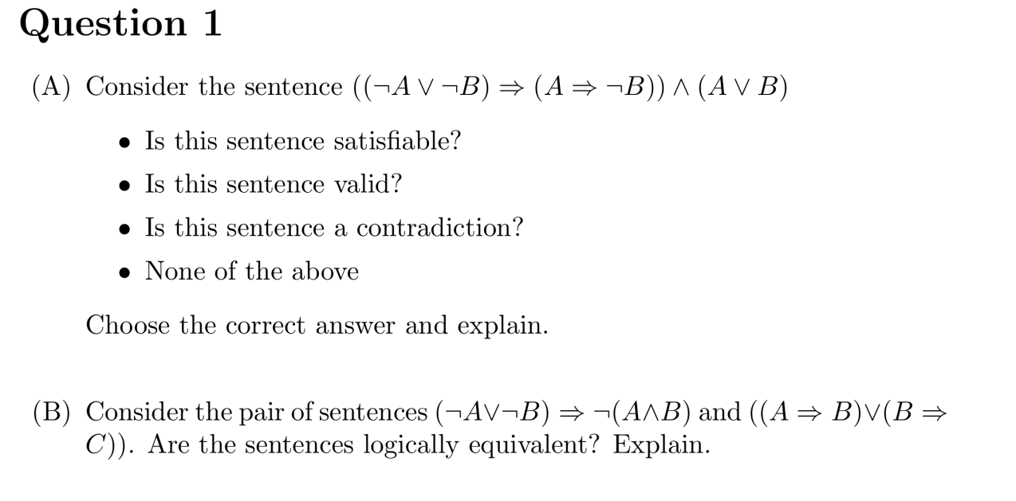、

**Answer 3:**

1. **satisfiable. We can draw the truth table for the statement:**

|  |  |  |  |  |  |  |
| --- | --- | --- | --- | --- | --- | --- |
| **A** | **B** | **¬A ∨ ¬B** | **A →¬B** | **(¬A ∨ B) → (A →¬B)** | **A ∨ B** | **the sentence** |
| 0 | 0 | 1 | 1 | 1 | 0 | 0 |
| 0 | 1 | 1 | 1 | 1 | 1 | 1 |
| 1 | 0 | 1 | 1 | 1 | 1 | 1 |
| 1 | 1 | 0 | 0 | 1 | 1 | 1 |

1. **There are logically equivalent. We can rewrite and simply both sentences into CNF:**

**(¬A ∨ ¬B) → ¬(A ∧ B)**

**= (¬A ∨ ¬B) → (¬A ∨ ¬B)**

**= ¬(¬A ∨ ¬B) ∨ (¬A ∨ ¬B)**

**= (A ∧ B) ∨ (¬A ∨ ¬B)**

**= (A ∧ B) ∨ (¬A ∨ ¬B)**

**= (A ∨ ¬A ∨ ¬B) ∧ (B ∨ ¬A ∨ ¬B)**

**Since both clauses contain something shaped like “P ∨ ¬P”, this statement is valid.**

**(A → B) ∨ (B → C)**

**= (¬A ∨ B ∨ ¬B ∨ C)**

**Since the clause contains something shaped like “P ∨ ¬P”, this statement is also valid.**

**Since both statements are valid, they can be equivalent logically.**

**Question 4**

Give the correct option (must, may, cannot) for each of the below

Given a sentence S and a truth assignment M for all symbols that occur in S:

1. if M is a model for S, then S {must, may, cannot} be consistent
2. if M is a model for S, then S {must, may, cannot} be a tautology
3. if M is a model for S, then S {must, may, cannot} be a satisfiable sentence

**Answer 4:**

1. **must**
2. **may**
3. **must**

**Question 5**

1. How can the attempt to construct a model for a logical formula **help to** prove the consistency or inconsistency of that formula?
2. How can you solve a puzzle by constructing a model for a logical formula?

**Answer 5:**

1. **If there is no model that can make the statement TRUE, then inconsistency can be proven; otherwise, if there is at least one model that can make the statement TRUE, then consistency can be proven.**
2. **To solve a puzzle, we can translate the puzzle stated in natural language into a puzzle defined in logical proposition. And a set of symbols is needed to represent different 0-1 strategic variables. And then we can use the DP algorithm to do the formal logic proposition satisfaction testing, and find a solution to the puzzle.**